**Sample Tables:**

**Table: Students**

student_id    student_name      age   class_id

1                       Alice                  18        101

2                       Bob                   17        102

3                       Carol                 18         101

4                       David                 17        103

**Table: Classes**

class_id       class_name

101                Math

102                Science

103                History

**Table: Scores**

student_id           subject score

1            Math              90

1           Science            85

2            Math              78

2           Science            92

3           Math                88

3           Science            79

4            History            95

Step 1:

1. Create database

CREATE DATABASE Sample_Tables;

USE Sample_Tables;

1. Create table :
2. Students table created

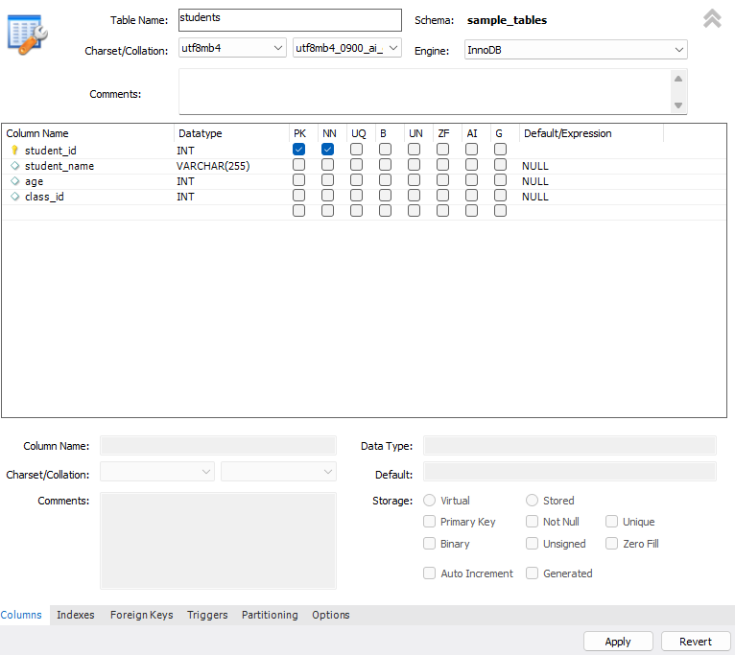

CREATE TABLE Students (

student_id INT PRIMARY KEY,

student_name VARCHAR(255),

age INT,

class_id INT

);

1. Classes table created



CREATE TABLE Classes (

class_id INT PRIMARY KEY,

class_name VARCHAR(255)

);

1. Create scores table

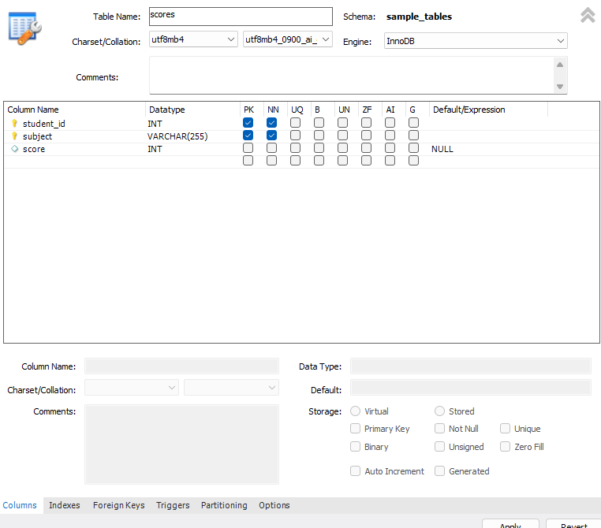

CREATE TABLE Scores (

student_id INT,

subject VARCHAR(255),

score INT,

PRIMARY KEY (student_id, subject),

FOREIGN KEY (student_id) REFERENCES Students(student_id)

);

**Queries :**

1. Question: For each class, find the student(s) who scored the highest in Science.

SELECT c.class_name, s.student_name

FROM Students s

JOIN Scores sc ON s.student_id = sc.student_id

JOIN Classes c ON s.class_id = c.class_id

WHERE sc.subject = 'Science'

AND sc.score = (SELECT MAX(score) FROM Scores WHERE subject = 'Science');



1. Question: List the names of students who scored lower in Math than their average Science score.

SELECT s.student_name

FROM Students s

JOIN Scores math_scores ON s.student_id = math_scores.student_id AND math_scores.subject = 'Math'

JOIN (SELECT student_id, AVG(score) AS avg_science_score FROM Scores WHERE subject = 'Science' GROUP BY student_id) avg_science ON s.student_id = avg_science.student_id

WHERE math_scores.score < avg_science.avg_science_score;



1. Question: Display the class names with the highest number of students who scored above 80 in any subject.

SELECT c.class_name, COUNT(DISTINCT s.student_id) AS num_students_above_80

FROM Students s

JOIN Scores sc ON s.student_id = sc.student_id

JOIN Classes c ON s.class_id = c.class_id

WHERE sc.score > 80

GROUP BY c.class_name

HAVING COUNT(DISTINCT s.student_id) = (SELECT MAX(num_students_above_80) FROM (SELECT COUNT(DISTINCT s.student_id) AS num_students_above_80

FROM Students s

JOIN Scores sc ON s.student_id = sc.student_id

WHERE sc.score > 80

GROUP BY s.class_id) AS temp);



1. Question: Find the students who scored the highest in each subject. */

SELECT sc1.subject, s.student_name, sc1.score AS highest_score

FROM Scores sc1 JOIN Students s ON sc1.student_id = s.student_id

WHERE (sc1.score, sc1.subject) IN ( SELECT MAX(sc2.score), sc2.subject

FROM Scores sc2 GROUP BY sc2.subject );

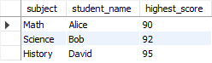

1. Question: List the names of students who scored higher than the average of any student's score in their own class.

SELECT s1.student_name, s1.class_id, sc1.subject, sc1.score

FROM Students s1 JOIN Scores sc1 ON s1.student_id = sc1.student_id

WHERE sc1.score > ( SELECT AVG(sc2.score) FROM Students s2

JOIN Scores sc2 ON s2.student_id = sc2.student_id

WHERE s2.class_id = s1.class_id);



1. Question: Find the class(es) where the students average age is above the average age of all students.

SELECT c.class_name

FROM Classes c

JOIN Students s ON c.class_id = s.class_id

GROUP BY c.class_name

HAVING AVG(s.age) > (SELECT AVG(age) FROM Students);



1. Question: Display the student names and their total scores, ordered by the total score in descending order.

SELECT s.student_name, SUM(sc.score) AS total_score

FROM Students s

JOIN Scores sc ON s.student_id = sc.student_id

GROUP BY s.student_name

ORDER BY total_score DESC;

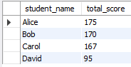

1. Question: Find the student(s) who scored the highest in the class with the lowest average score.

SELECT s.student_name

FROM Students s

JOIN Scores sc ON s.student_id = sc.student_id

WHERE s.class_id = (SELECT class_id FROM (

SELECT class_id, AVG(score) as avg_score

FROM Scores

GROUP BY class_id

ORDER BY avg_score ASC

LIMIT 1

) AS lowest_avg_class)

ORDER BY sc.score DESC;



1. Question: List the names of students who scored the same as Alice in at least one subject.

SELECT DISTINCT s.student_name

FROM Students s

JOIN Scores sa ON s.student_id = sa.student_id

WHERE sa.score = (SELECT score FROM Scores WHERE subject = (SELECT subject FROM Scores WHERE student_id = 1) AND student_id = 1);

1. Question: Display the class names along with the number of students who scored below the average score in their class.

SELECT c.class_name, COUNT(*) AS num_students_below_avg

FROM Students s

JOIN Scores sc ON s.student_id = sc.student_id

JOIN Classes c ON s.class_id = c.class_id

WHERE sc.score < (SELECT AVG(score) FROM Scores WHERE subject = sc.subject)

GROUP BY c.class_name;

